ETL Processing Final
In this final you will create an entire ETL solution. This activity will take you about 15 to 20 hours, so plan accordingly!
Table of Contents
ETL Processing Final 1
Step 1. Create a Blank Visual Studio Solution 2
Step 2. Review and Estimate Time for Tasks 2
Step 3. Create the OLTP Databases 3
Step 4. Create a Data Warehouse 5
Step 5. Review the Daily Import Files 6
Step 6. Start the Solution Developer Document in Excel 6
Step 7. Create an ETL script 7
Step 8. Create a SSIS ETL project 7
Step 9. Automate the Backup of all three databases 8
Step 10. Create a Technical Overview Document 9
Step 11. Write a One-page Report 9
Step 12. Update the Final Checklist.xlsx file 9
Step 13. Submit your Solution to the Canvas site 9

Step 1. Create a Blank Visual Studio Solution
You will create a complex ETL processing solution with lots of code and documentation files. You must organize these files into a single VS solution. Make sure to add both physical and virtual folders to the solution to complete the organization.

Step 2. Review and Estimate Time for Tasks
Use the provided file to estimate the number of hours you think this will take to perform your work. Students get very worried about this, but all you need to do is make an educated guess so that later you can how well you guessed. This will help you in future planning! Points are not deducted from guessing incorrectly.

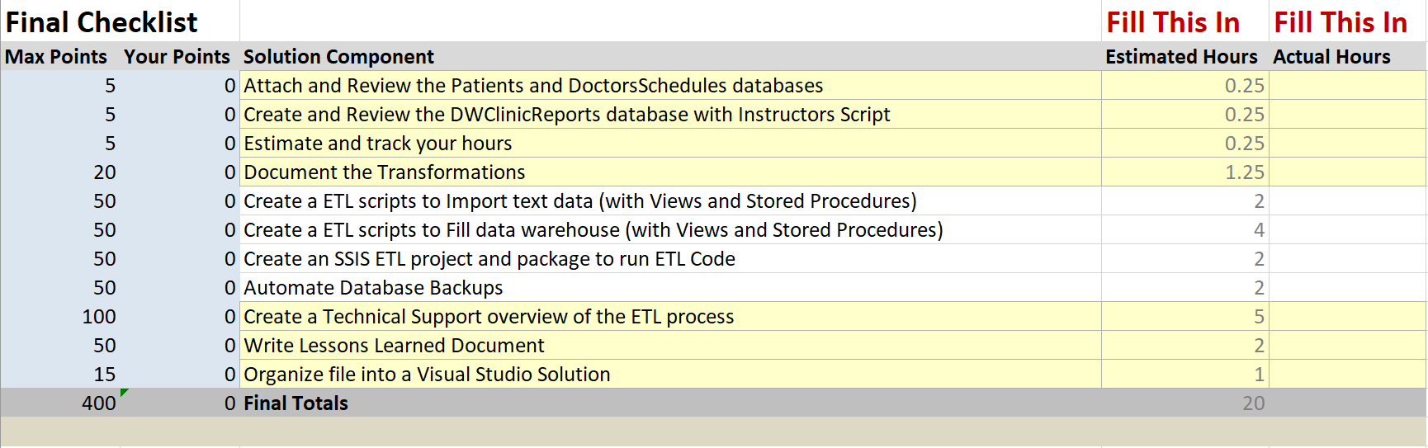
Figure 1: The Final Checklist

Note: You will find the file here: "Info 498 Final\Documents\Final Checklist.xlsx"

Step 3. Create the OLTP Databases
You need to attach the two source databases called DoctorsSchedules and Patients. The .MDF files for each database (file names: DoctorsSchedules.mdf, Patients.mdf) are included in the final's zip file (folder name: Patients Doctors Clincs DBs). You need to attach both of these databases to your SQL Server installation.

Note: The Doctors Schedules database is found in the file, "Info 498 Final\Databases\DoctorsSchedules.mdf"

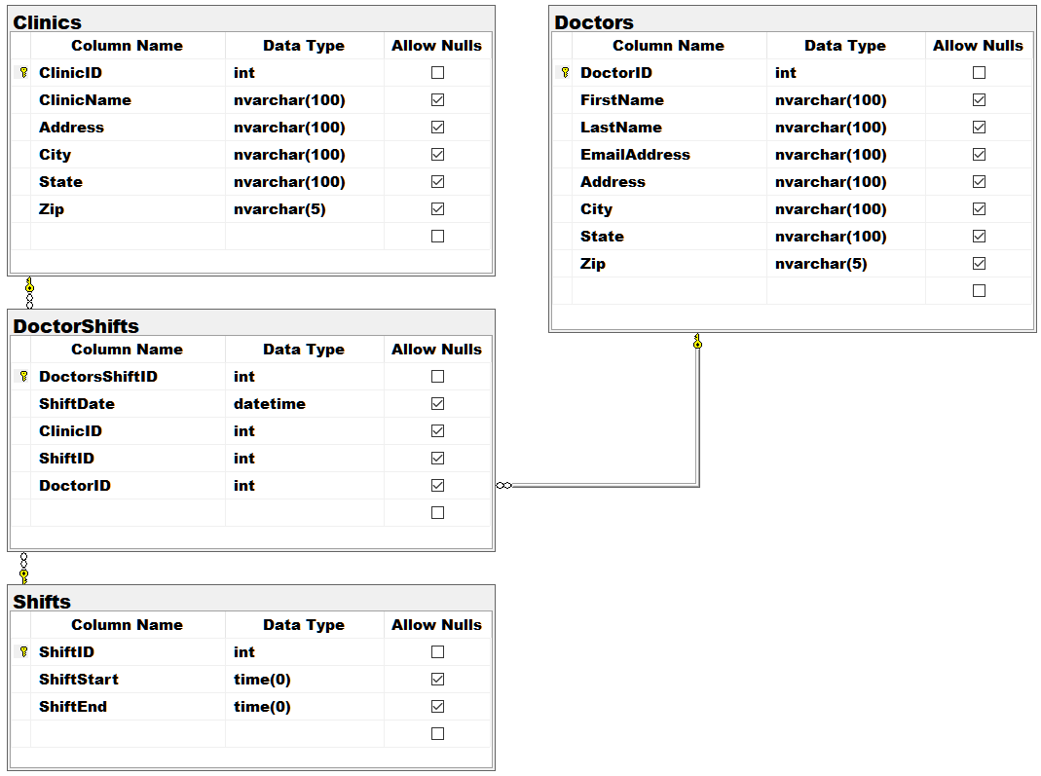
Figure 2. The DoctorsSchedules Database

Note: The Patients database is found in the file, "Info 498 Final\Databases\Patients.mdf"

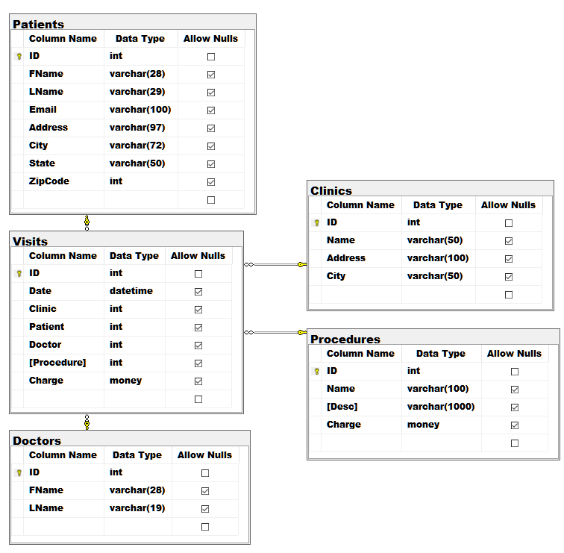
Figure 3. The Patients Database

Step 4. Create a Data Warehouse
I have given you a data warehouse database script, to create ETL destination database. Review this database design for your ETL process!

NOTE: The DWClinicReportData database is found in the file,
"Info 498 Final\Databases\Create DWClinicReportData.sql"

Note: The data warehouse contains only one Type-2 table design that you must handle, but all other tables are the Type-1 design.

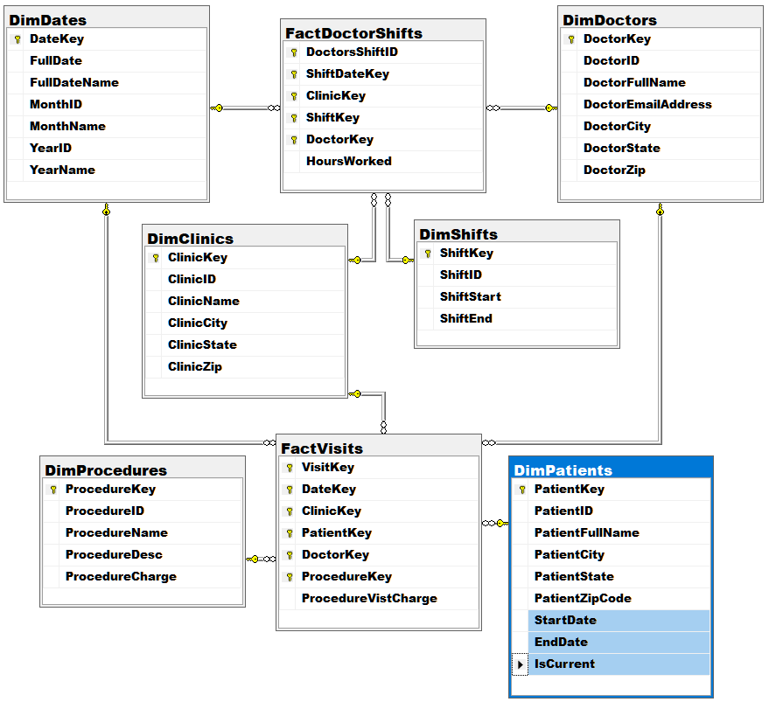
Figure 4. The DWClinicReportData Database

Step 5. Review the Daily Import Files
There are two sets of .CSV files to processed. These files represent data to be added daily to the source databases. Review each database and file, noting the many issues in their design and data!

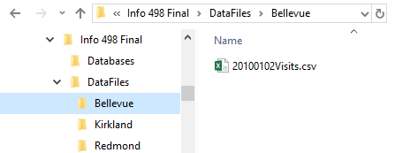
Figure 5. Examples of the daily data CSV files

Notes:
- One of the clinics is not formatting the CSV correctly (the Clinic ID is missing)! You must figure out either a SQL or Non-SQL way to fix this
- The files can be found here: "Info 498 Final\DataFiles"

Step 6. Start the Solution Developer Document in Excel
You need to document your development of the solution using a developer spreadsheet (you do not need a formal Word document in this course). Use the Excel spreadsheet I have provided as a starting point. I have a lot of it filled in already, but you need to fill in the missing destination and transformation metadata needed to describe your ETL process.

Note: The file can be found here: "Info 498 Final\Documents\BISolutionWorksheets.xlsx"

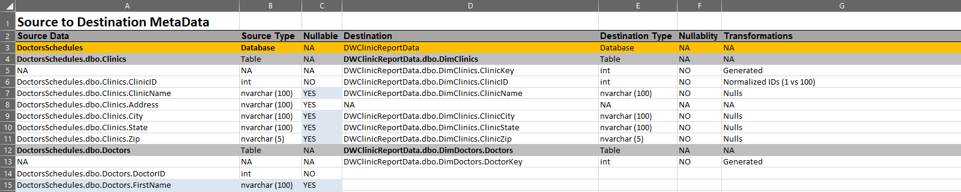
Figure 6. The Solution Development Metadata Worksheet

Step 7. Create an ETL scripts
You need to create two ETL SQL script for your solution. Make sure they include views and stored procedures. The ETL process must:

- Incrementally load the CSV data into the OLTP databases.
- Flush and Fill most table in the data warehouse with OLTP database data.
  - Incrementally load the DimPatients table

I have provided
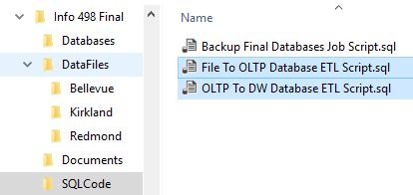
Figure 7. The ETL Script Files

Note: The files can be found here: "Info 498 Final\SQLCode\ "

Step 8. Create a SSIS ETL project
You need to create an SSIS ETL project and package to perform the ETL processing from the CSV file to the OLTP database and from the OLTP database into the Data Warehouse database.

Notes:
- Please use a single SSIS package for the final (to keep things simple)
- The SSIS package must work through Views and/or Stored Procedures
- You can use Data Flows or Execute SQL Tasks
- Do not put SQL files in the SSIS project. Put them in Solution folders instead

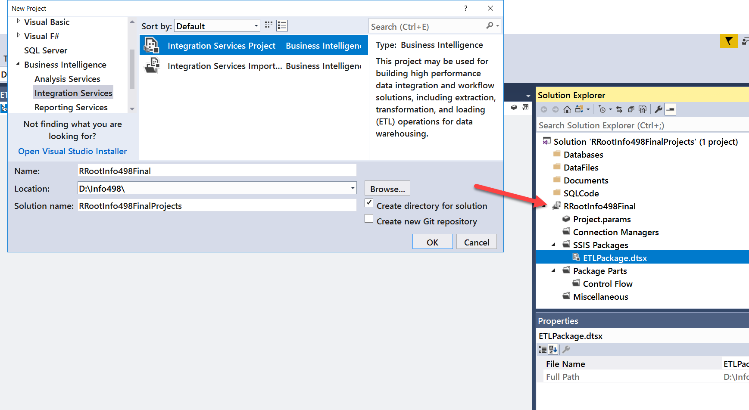
Figure 8. The ETL SSIS Project

Step 9. Automate the Backup of all three databases
You need to create a SQL Agent job that performs a daily backup of each of the three databases. Once the job is created, create a SQL script for the creation of the job and add it to your Visual Studio solution.

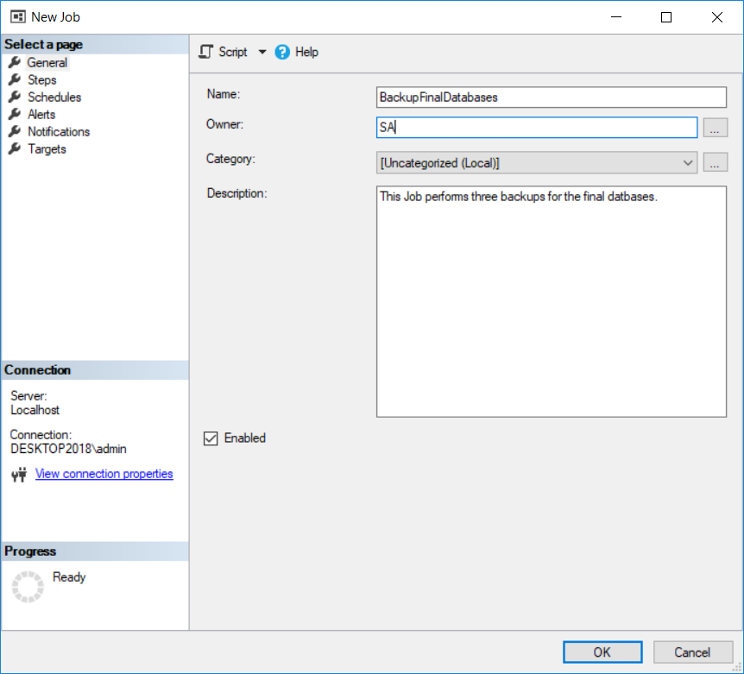
Figure 9. The SQL Agent Backup Job

Step 10. Create a Technical Overview Document
Next, you need to create a technical overview document that describes the ETL process you have created. Any reader should be able to read your documents and understand what all the solution's components are, why are used, and how they are used.

Tip: You may need to update your Excel worksheet to accurately record the objects in your solution to make sure your final documentation reflects what was built.

Step 11. Write a One-page Report
Write a paper that outlines what you have learned in this class. This helps both you and I to understand you progress in this class. You may be surprised to see that this process solidifies what you have learned (or at least other students have told me it does!) There is no need to make this an exhaustive coverage of what you did but do make the paper at least a few paragraphs of well written text.

Note: This is a college level class and I expect college level writing and formatting. It does not have to be perfect, but if you turn in a blob of text without a header or citing it will cost you.

Step 12. Update the Final Checklist.xlsx file
Use this file to check that you have complete all the steps and update the number of hours it took to do the final.

Step 13. Submit your Solution to the Canvas site
After you have configured and tested your solution, ZIP the entire solution folder and upload it to the Canvas web site. Remember that you will have placed all the files for the ETL scripts, SSIS, Excel ETL and Checklist spreadsheets and Word docs into one solution folder. Zip everything up into one Zip file and submit it to canvas.

Notes: Make sure that all the documents, code files, database files, CSV files, SSIS project and SSAS projects are all under one VS solution and in that solutions folder!

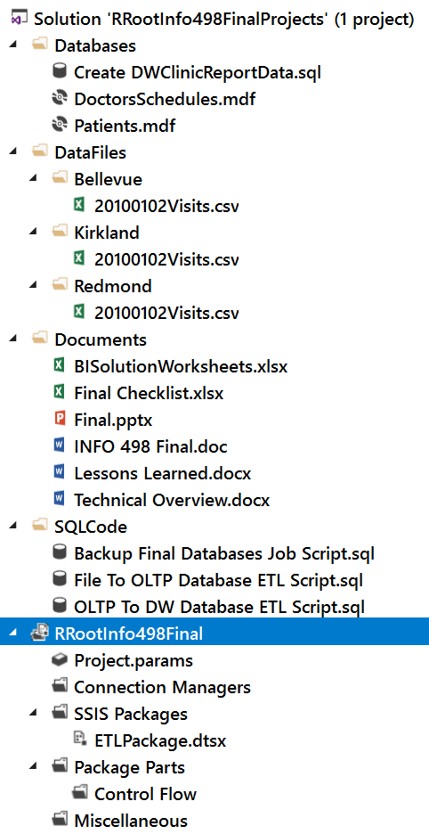
Figure 10. The files of the project’s solution.

You’re done! And, this time I really mean it!! ☺
Thanks for being in the class!!!

